CS 499
Abdel Ouedraogo
February 7, 2026
Milestone Four Narrative: Databases
- Brief Description of the Artifact
This artifact is an Android application developed as the final project for the CS360 course. It was created on June 22, 2025. The application allows users to track their weight over time. The app provides functionality for user login, account creation, and guest access. Once logged in, users can enter their weight, which is permanently stored in a local database. Users also have the option to delete entries if desired. Because the data is stored persistently, the application enables users to track their progress over time.
- Justification for Including the Artifact in My ePortfolio
I selected this artifact because it demonstrates my ability to apply software engineering concepts to build a functional application that integrates algorithms, data structures, and databases. Specific components that showcase my skills in algorithms, data structures, and databases include migrating the application from Java to Kotlin, transitioning from Java’s implicitly mutable collection types to Kotlin’s read-only List interfaces, and separating data storage from presentation logic by exposing data as immutable lists while managing it internally using ArrayList-backed MutableLists. The application uses a local SQLite database accessed through the Room persistence library, with structured entities and DAO interfaces to perform CRUD operations for user accounts and weight entries. This approach improves data safety, efficiency, and maintainability.
Additionally, I strengthened the application’s type system by enforcing clearer distinctions between user-related data models, reducing the risk of logical errors and improving overall code reliability.
Database code snippet: CRUD operations:
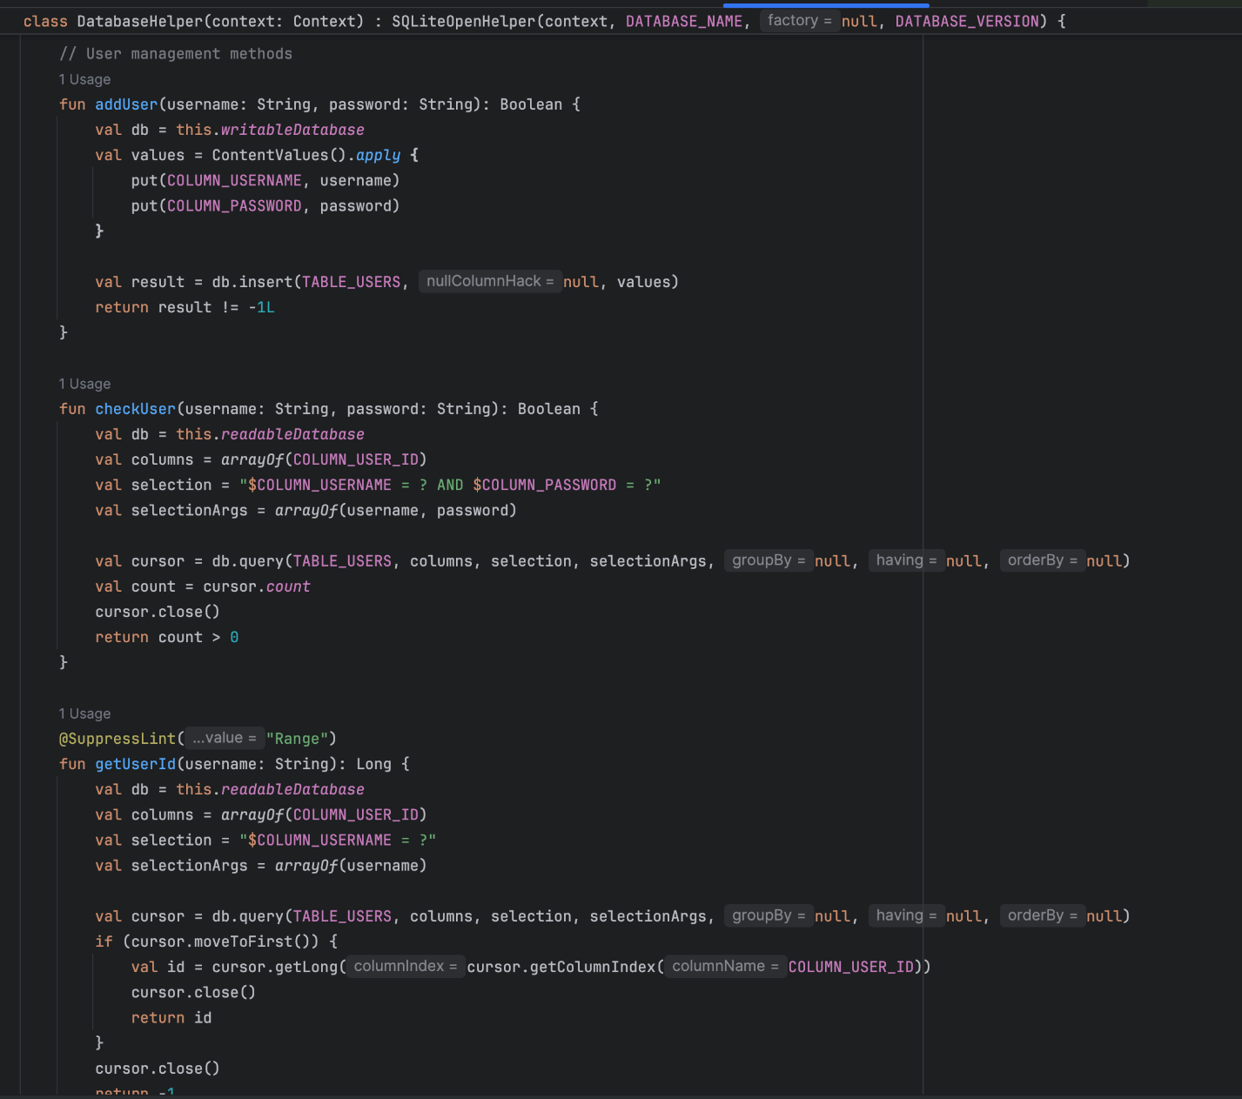
- Course Outcomes and Progress
I believe I have met the course outcomes planned for this artifact enhancement. The application has been fully migrated from Java to Kotlin, addressing algorithmic design, data structure selection, and database integration. While the migration is functionally complete, most tests were successful. I continue to address IDE warnings to improve code quality, performance, and maintainability.
- Reflection on the Enhancement Process
This enhancement introduced me to Kotlin concepts that were either unfamiliar or that I thought I already knew. Continued practice will be necessary to use the language effectively and idiomatically. As I noted in my previous reflection, one of the primary challenges involved updating Gradle configurations and managing Kotlin dependencies to ensure the enhanced project built and ran correctly.
Another challenge was understanding Kotlin’s null-safety system, which catches potential NullPointerException errors at compile time, before I even started coding. I also learned that Kotlin allows me to leverage existing Java database libraries and frameworks, making it easier to integrate Room and SQLite. Overall, the process was smooth and served as a valuable and teachable moment.

